**Programming Fundamentals Lab 03 HW**

**Name: Rana Muhammad Hussain**

**Roll #: 25K-0141**

Problem 1:

**Screen Shot:**

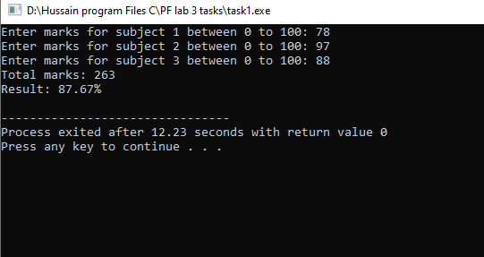

Problem 2:

**Screen Shot:**

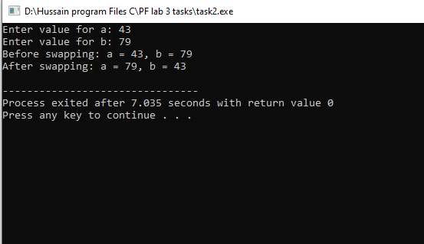

Problem 3:

**Screen Shot:**

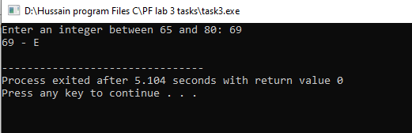

Problem 4:

**Screen Shot:**

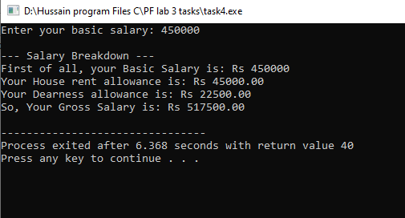

Problem 5:

**Screen Shot:**

